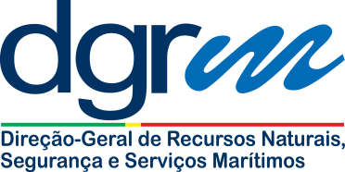

|  |  |
| --- | --- |
| **Subject:** | **Report of defect or accidental damage** |

**NOTE:**

1. Please complete this application form and submit it to the Recognized Organization (RO)
2. The RO is kindly requested to give its position on the company’s proposal and forward the application to the Portuguese Maritime Administration ([marad@dgrm.mamaot.pt](mailto:marad@dgrm.mamaot.pt));

|  |  |  |  |  |  |
| --- | --- | --- | --- | --- | --- |
| Name: |  | | Company: |  | |
| Telephone: |  | | Fax: |  | |
| Email: |  | | Date: |  | |
|  | | | | | |
| Name of the vessel: | |  | Ship type: | |  |
| Gross Tonnage: | |  | IMO number: | |  |
| Keel laid date: | |  | Recognized Organization: | |  |

|  |
| --- |
| 1. Description of the defect: |
| 1. Corrective/mitigating action taken: |
| 1. Complete corrective action (proposed plan): |

|  |
| --- |
| **Recognized Organization comments** |
|  |

|  |  |  |
| --- | --- | --- |
| **FOR THE MARITIME ADMINISTRATION USE ONLY** | | |
| Comments: | | |
| Date: | Name authorized person: | Signature of the authorized person: |