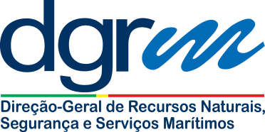

|  |  |
| --- | --- |
| **Subject:** | **Malfunction equipment required by SOLAS/IV/4.8 or SOLAS/V regulations (application for authorization to continue operation)** |

**NOTE:**

1. Please complete this application form and submit it directly to the Portuguese Maritime Administration ([marad@dgrm.mamaot.pt](mailto:marad@dgrm.mamaot.pt));

|  |  |  |  |  |  |
| --- | --- | --- | --- | --- | --- |
| Name: |  | | Company: |  | |
| Telephone: |  | | Fax: |  | |
| Email: |  | | Date: |  | |
|  | | | | | |
| Name of the vessel: | |  | Ship type: | |  |
| Gross Tonnage: | |  | IMO number: | |  |
| Keel laid date: | |  | Recognized Organization: | |  |

|  |
| --- |
| 1. Description of the malfunctioning equipment: |
| 1. Reasons for the application: |
| 1. Corrective action plan (anticipated location/date for completion of repairs): |

|  |  |  |
| --- | --- | --- |
| **FOR THE MARITIME ADMINISTRATION USE ONLY** | | |
| Taking in consideration regulations SOLAS/IV/15.8 and SOLAS/V/16.2, the Portuguese Maritime Administration acknowledges the malfunctioning of the equipment described above and authorizes the ship to continue her operation, while taking all steps to repair the equipment, until: | | |
| Date: | Name authorized person: | Signature of the authorized person: |